AST Intranet System

Company Wall

Corporate Video
Advanced Sys-tek Ltd.
(Short desc, image and website link)
AST Environment Solution  (Short desc, image and website link) |  | Terranomous  (Short desc, image and website link)
Birthday Wishes & Work Anniversary
In the Form of slider
Orders Received in the Month
in the form of Slider
Eresource  Short Desc  Direct link | Spine HR  Short Desc  Direct link | CIM  Short Desc  Direct link |  |  | CRR  Short Desc  Direct link
Induction Manual  (One line description and preview link) | Exit Manual  (One line description and preview link) | Other Manuals  (Opens the Manual Page)
Policies  (Opens a page where all the policies are listed down) |  | Resources  (Opens a page where all the policies are listed down) | Townhall link  (Link townhall page)
Organization  (Opens up employee page) |  | New Joinee Information  (Picture and designation) |  | Open Positions  (open a page of open position)
Cafeteria Menu for the week | Contact List | Holiday Calendar for the year |  |  | Upcoming Training Calendar
Employee Achievements
(with images and a one liner description on achievement, grid form)
Upcoming Events (One line Description)

Link to Pictures of the last event taken place along with a one liner description

Organization

Software  (Short Description of the dept,  When clicked on list of team members become visible) | Customer Service  (Short Description of the dept,  When clicked on list of team members become visible) | HR  (Short Description of the dept,  When clicked on list of team members become visible)
Plant Operations  (Short Description of the dept,  When clicked on list of team members become visible) | Finnance & Accounts  (Short Description of the dept,  When clicked on list of team members become visible) | Sales & Proposals  (Short Description of the dept,  When clicked on list of team members become visible)
Business Development  (Short Description of the dept,  When clicked on list of team members become visible) | Projects  (Short Description of the dept,  When clicked on list of team members become visible) | Engineering & Operations  (Short Description of the dept,  When clicked on list of team members become visible)
Add Org Chart, name and designation, PDF

Employee List

List of all employees with relevant information (same as that shown in CIM)

Policies

List of Policies along with their documents.
- Inter department Transfer policy
- Employee Referral Policy
- Overseas Travel Policy
- Domestic Travel Policy
- IT Policy
- Induction Policy
- Exit Policy

Town Hall
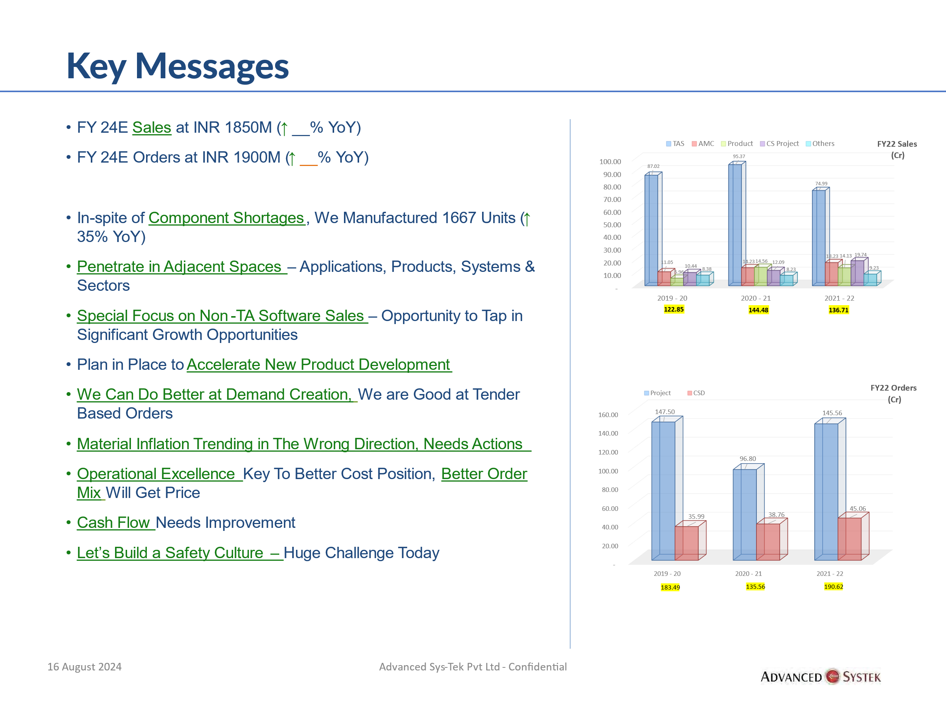

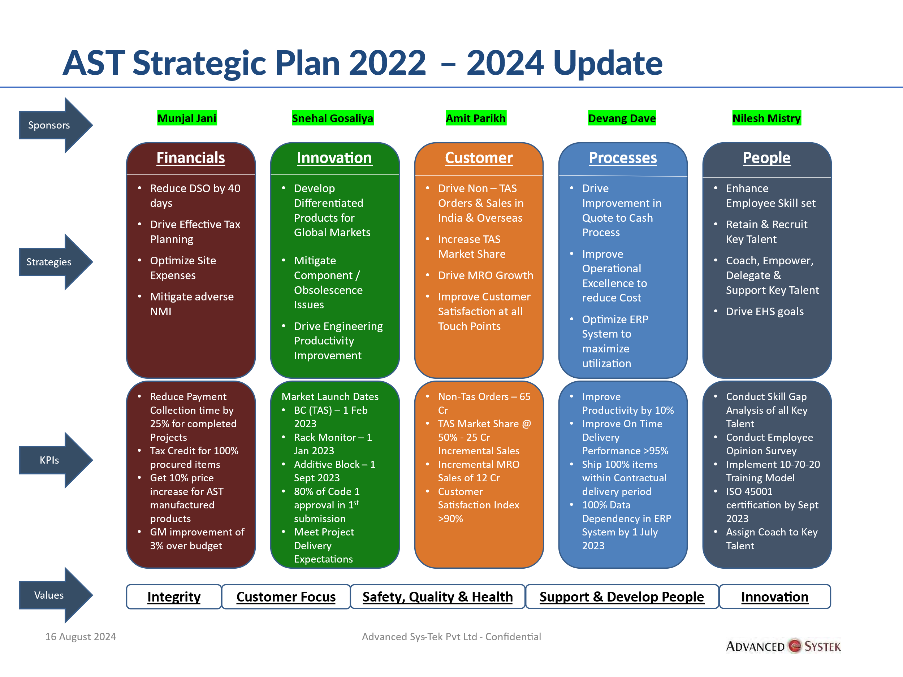

Resources
List of Resources, in terms of free to use software, tools, applications, company logo, templates, Power point presentation, email signatures etc.

Files
Link to server
Department wise access to File server folders
Software  (Short Description of the dept,  When clicked on list of team members become visible) | Customer Service  (Short Description of the dept,  When clicked on list of team members become visible) | HR  (Short Description of the dept,  When clicked on list of team members become visible)
Plant Operations  (Short Description of the dept,  When clicked on list of team members become visible) | Finnance & Accounts  (Short Description of the dept,  When clicked on list of team members become visible) | Sales & Proposals  (Short Description of the dept,  When clicked on list of team members become visible)
Business Development  (Short Description of the dept,  When clicked on list of team members become visible) | Projects  (Short Description of the dept,  When clicked on list of team members become visible) | Engineering & Operations  (Short Description of the dept,  When clicked on list of team members become visible)

Manuals
CIM  (List of related manuals) | CRR  (List of related manuals) | Eresource  (List of related manuals)
Spine HR - Expense  (List of related manuals) | Spine HR - Timesheet  (List of related manuals) | Spine HR - Payroll  (List of related manuals)
Product manuals  (List of related manuals) | Others  (List of related manuals)

